H.T No
Regulations:
A22

Sreenidhi Institute of Science and Technology
(An Autonomous Institution)
Code No:9A201 Date: 11-July-2025 (FN)

B.Tech I-Year II- Semester External Examination, July-2025 (Regular)
ELECTRICAL CIRCUITS AND NETWORKS-I (EEE)

Time: 3 Hours Max.Marks:60

Note: a) No additional answer sheets will be provided.
b) All sub-parts of a question must be answered at one place only, otherwise it will not be valued.
c) Missing data can be assumed suitably.
Bloom's Cognitive Levels of Learning (BCLL)

Remember | L1 | Apply | L3 | Evaluate | L5
Understand | L2 | Analyze | L4 | Create | L6

Part - A Max.Marks: 6x2=12

Answer all QUESTIONS, EACH QUESTION CARRIES 2 MARKS.

 |  | BCLL | CO(s) | Marks
1 | Define the Independent and Dependent Sources. How they are classified? | L1 | CO1 | [2M]
2 | What is Planar and Non planar network? | L2 | CO2 | [2M]
3 | Define reluctance and magnetic field intensity. | L1 | CO3 | [2M]
4 | Define the term RMS value. | L1 | CO4 | [2M]
5 | Draw locus diagram for RL series circuit with varying R. | L2 | CO5 | [2M]
6 | State Superposition theorem. | L1 | CO6 | [2M]

Part – B Max.Marks: 6x8=48
ANSWER ALL QUESTIONS. EACH QUESTION CARRIES 8 MARKS.

 |  | BCLL | CO(s) | Marks
7 | Find the current through 20 Ω resistor using Kirchhoff’s laws  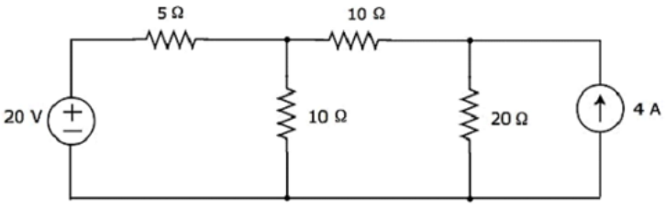 | L4 | CO1 | [8M]
 | OR
8 | Obtain the relationship between star to delta conversion. | L3 | CO1 | [8M]
9 | For the given network graph shown in figure, write down the basic Tie-set matrix, taking the tree consisting of edges 2,4 and 5.  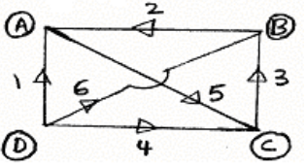 | L4 | CO2 | [8M]
 | OR
10 | Draw the dual of the following network shown in figure  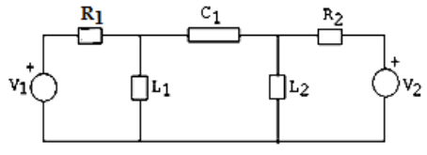 | L4 | CO2 | [8M]
11 | State and explain Faraday’s law of electromagnetic induction. | L3 | CO3 | [8M]
 | OR
12 | Explain the terms self-inductance, mutual inductance and coefficient of coupling as applied to a magnetic circuit. With usual notation, establish the relationship between mutual inductance, self-inductance and coefficient of coupling. | L3 | CO3 | [8M]
13 | An alternating voltage is given by V=230sin314t. Calculate i) frequency ii) maximum value, iii) average value, iv) RMS value | L3 | CO4 | [8M]
 | OR
14 | For the waveform shown find the Form factor?  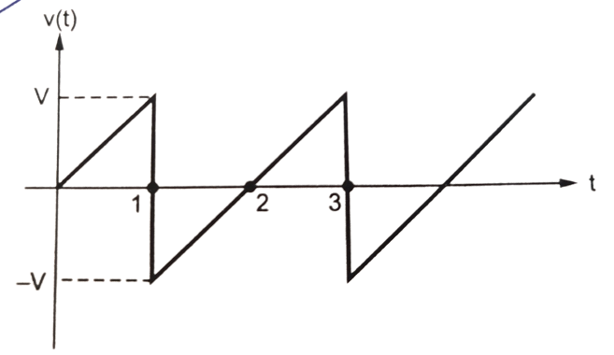 | L3 | CO4 | [8M]
15 | Obtain the expression for resonant frequency and Bandwidth for Series R-L-C circuit. | L3 | CO5 | [8M]
 | OR
16 | A coil of R = 4 ohms, X_{L}= 3 ohms connected in series with a condenser of R = 8 ohms, Xc= 8 ohms, this combination is connected to 4 ohms resistor. Across this series circuit a voltage 100 volts is applied. Calculate: i) current ii) voltage drops across coil, condenser and resistor and iii) power absorbed by the circuit. | L4 | CO5 | [8M]
17 | Verify the reciprocity theorem for the network shown in the figure  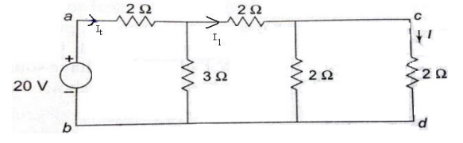 | L3 | CO6 | [8M]
 | OR
18 | Find the current through 2Ω resistor using Thevenin’s theorem shown in figure  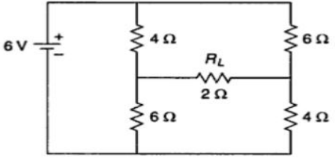 | L4 | CO6 | [8M]

-- 00 -- 00 –

